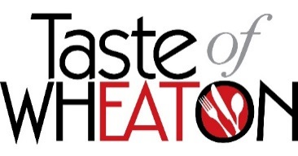

Sunday, June 12, 2022
11am – 5 pm

Business/County Agency Exhibit Booth Application

The Taste of Wheaton is an annual festival highlighting local restaurants in downtown Wheaton. Exhibitor ooths are available for $150 to businesses located within downtown Wheaton, and Montgomery County agencies (fee is waived for county agencies). Space is limited for non-food related businesses and priority will be given to county agencies and businesses located in the Wheaton Urban District.

Please complete this form and email to: Sidney.cooper@montgomerycountymd.gov or drop off to: Sidney Cooper, Wheaton Urban District, 2425 Reedie Drive, 2nd floor, Wheaton MD, 20902. Applications and payment (if applicable) must be received by Friday, May 20, 2022. Please make checks payable to “Wheaton Urban District”.

Please provide the following information:

Agency/Business Name: ________________________________________________________

Event day contact name: ________________________________________________________

Phone: ______________________________________________________________________

Email: _______________________________________________________________________

Your booth includes a 10 x 10’ tent, 1 table, 2 chairs, and a small company sign. You are permitted to bring additional signage, tablecloth or banners if desired. All signage must be displayed within the confines of your booth. You are not permitted to distribute literature or solicit outside of your assigned space. Booths will be located on Grandview Avenue and will be pre-assigned and marked by signage when you arrive. The event runs from 11:00 am to 5:00 pm, rain or shine.

You can access Grandview Avenue with a vehicle between 8:00 am and 10:00 am. All cars must be moved from the event area by 10:00 am. Parking can be found at the Wheaton Marketplace Garage conveniently located on Grandview Avenue. There is no parking within the event area.

You will receive booth confirmation and additional event information the week of May 30. For question regarding the event, email sidney.cooper@montgomerycountymd.gov.

